Even Semester (2019)



**BINUS UNIVERSITY**



**BINUS INTERNATIONAL**



**Assignment Cover Letter**

**(Individual Work)**

|  |  |  |  |  |  |  |  |
| --- | --- | --- | --- | --- | --- | --- | --- |
|  |  | | |  |  |  |  |
| **Student Information**: | **Surname** | | |  |  | **Given Names**  **Wely** | **Student ID Number**  **2201808365** |
| 1. | **Dharma Putra** | |
|  |  |  |  |  |  |  |  |
| **Course Code** | **: COMP6510** |  |  |  |  | **Course Name** | **: Programming Language** |
| **Class** | **: L2BC** |  |  |  |  | **Name of Lecturer(s)** | : Minaldi Loeis |
|  |  |  |  |  |  |  |  |
| **Major** | **: CS** |  |  |  |  |  |  |
| **Title of Assignment**  (if any) | : YouNotes |  |  |  |  |  |  |
| **Type of Assignment**    **Submission Pattern** | **: Final Project** | |  |  |  |  |  |
| **Due Date** | **: 01 - 07 - 2019** | |  |  |  | **Submission Date** | **: 01 – 07 -2019** |

The assignment should meet the below requirements.

1. Assignment (hard copy) is required to be submitted on clean paper, and (soft copy) as per lecturer’s instructions.
2. Soft copy assignment also requires the signed (hardcopy) submission of this form, which automatically validates the softcopy submission.
3. The above information is complete and legible.
4. Compiled pages are firmly stapled.
5. Assignment has been copied (soft copy and hard copy) for each student ahead of the submission.

# Plagiarism/Cheating

Binus International seriously regards all forms of plagiarism, cheating and collusion as academic offenses which may result in severe penalties, including loss/drop of marks, course/class discontinuity and other possible penalties executed by the university. Please refer to the related course syllabus for further information.

# Declaration of Originality

By signing this assignment, I understand, accept and consent to Binus International terms and policy on plagiarism. Herewith I declare that the work contained in this assignment is my own work and has not been submitted for the use of assessment in another course or class, except where this has been notified and accepted in advance.

Signature of Student: (Name of Student)

Wely Dharma Putra

**II. Table of Contents**

1. **Cover**
2. **Table of Content**
3. **Project Specifications**
4. **Solution Design**
5. **Code Implementation Discussion**
   1. **Implementation**
   2. **How it works**
6. **Evidence of Working Programme**
   * 1. **Login**
     2. **Register**
     3. **Album page**
     4. **Notes page**
     5. **Inside Notes**
     6. **Adding**
     7. **Deleting**
     8. **Writing Notes**
7. **Reference**

**III. Project Specifications**

First, the problem that we see now days, there are lot of student in some university still using a paper to write something, for examples: the material and others.

As a student in University, I know how hard it is to writes down all material. Sometimes, it is very hard to find the materials that I wanted to use. Not even that now days, there are people still using a paper or only using Microsoft word, because if we are using Microsoft word we needs to save it in a folder and it bit hard to find.

All in all, it is not an efficient way to write down all materials or the others.

So, in this project, I have made a program that makes everyone write their material easily and more efficient to do.

For this project, I use mySQL as my database, Java FX with sceneBuilder for my GUI, intelliJ for my IDE and a server.

**IV. Solution Design**

Below is the UML for the final project.

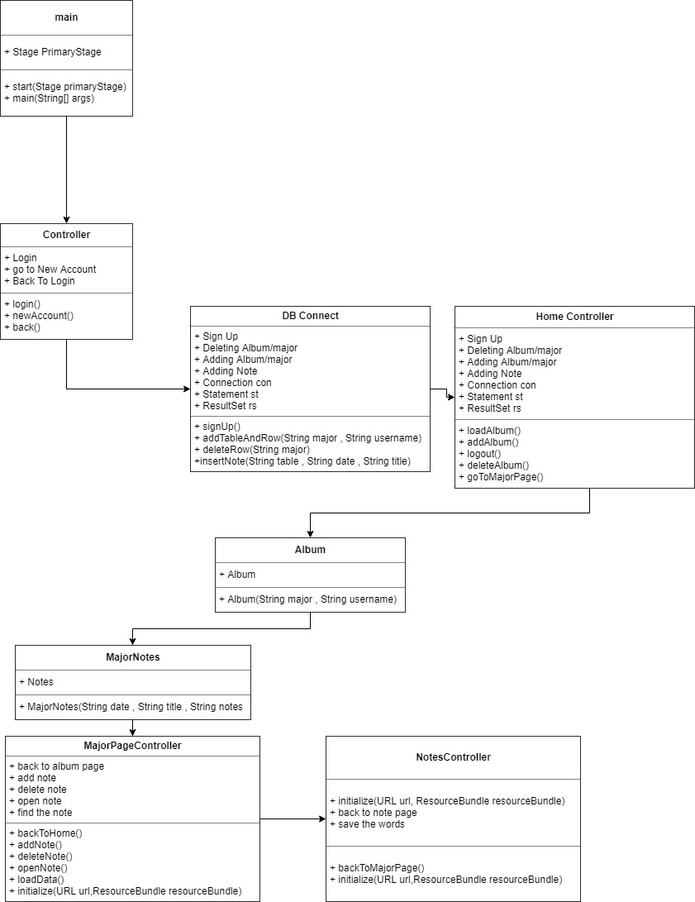

**V. Code Implementation Discussion**

**i. Implementation**

For this project, I use Java FX with sceneBuilder to build the user interface and I use mySQL for the database that stores all the users and the posts from Binus Activity with using XAMPP to connect from the local host or server to mySQL and apache.

This project imports many different packages from javafx for the GUI, java.time to collect the local current data and format the date, java.sql to connect with a database and an array list.

import javafx.fxml.FXML;   
import javafx.fxml.FXMLLoader;   
import javafx.fxml.Initializable;  
import javafx.scene.Parent;  
import javafx.scene.Scene;   
import javafx.scene.control.TextField;  
import javafx.scene.text.Text;  
import java.io.IOException;  
import java.net.URL;  
import java.sql.Connection;  
import java.sql.ResultSet;  
import java.sql.SQLException;  
import java.util.ResourceBundle;  
  
import java.time.LocalDate;  
import java.time.format.DateTimeFormatter;  
import java.util.ResourceBundle;

ii. How it works

To understand how the code works, the explanation will be divided into different sections.

1. Login page
2. Register page
3. Album Page
4. Notes page
5. Inside Notes

Let us begin with the first,

**i. Login Page**

When the programme starts, the Login page will launch on the screen and ready run the program.

in the login page you can input the username and the password to log in. If there is no account yet, there is the button to the register page.

public void login()

This is the function that will check if the username and password available or not. Then, if there is an account that already registered, it will open the Album page.

public void newAccount()

This is function that will open the Register page, so we can register the new account.

**ii. Register Page**

The user that still do not have an account, can creates an account in this page. After the user created the account, the user can use the program now.

public void signUp()

This function is that the user use for inputs the new username and password to the database, so when every time the user wants to login, the user just can insert the username and password.

**iii. Album Page**

The album page is the page where the user can create and deleting an album. The reason why we use an album is for dividing the user’s majority, for example when the student using this this program for dividing the courses.

public Album(String major , String username)

This Function is for making the album table read as object.

public void deleteRow()

public void deleteAlbum()

This Function is to delete which album that the user wants to delete.

public void addTableAndRow()

public void addAlbum()

This is the function that will add the new album to the database and add “_” + username in the back of the album’s name. Then, it will turn into a new table in database.

**iv. Notes Page**

The notes page is almost the same page like album page, but in this program notes is inside of an album. Then, if the user is a student, so the user can divides which material that the user has written.

DateTimeFormatter dtf = DateTimeFormatter.*ofPattern*("dd/MM/yyy");  
LocalDate date = LocalDate.*now*();  
  
@FXML  
Text majorText;  
  
@FXML  
TextField titleText;  
  
@FXML  
private TableView<MajorNotes> tableView;  
@FXML  
private TableColumn<MajorNotes,String> dateCol;  
@FXML  
private TableColumn<MajorNotes,String> titleCol;

This programme collects the local date in a form of string. Then, the programme will get the text from the different text areas.

public void addNote()

This function is for the user to add a new note and when the user creates a note, it also will input the local data.

public void insertNote(String table , String date , String title)

Then, in this program the note that has been created will be inserted into database.

public void deleteNote()

This function is for deleting the note.

public void openNote()

this function will find the data of note that selected by the user.

**v. Inside Notes**

In the inside of the note, the user can write anything that he/she wants to write. So, when a student uses this program, they could use this to write their material in this note.

public void backToMajorPage()

This function is for when the user has been writing something and the user press the back button and the note will be updated.

**VI. Evidence of Working Programme**

**i. Login page**

This window is the login page. When the programme launches

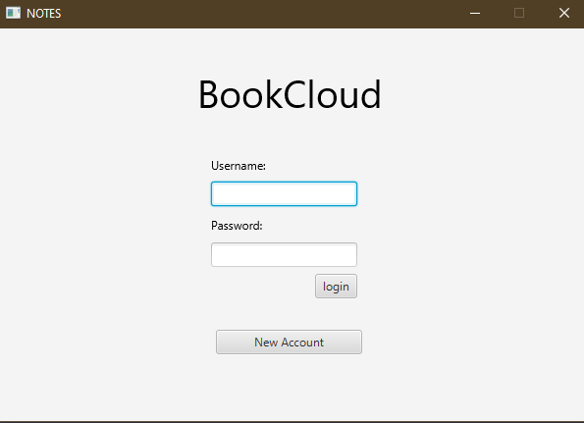  
 Login the page and just insert the username and password. Then, press the login button or if there is still no an account just press new account button.

**ii. register page**

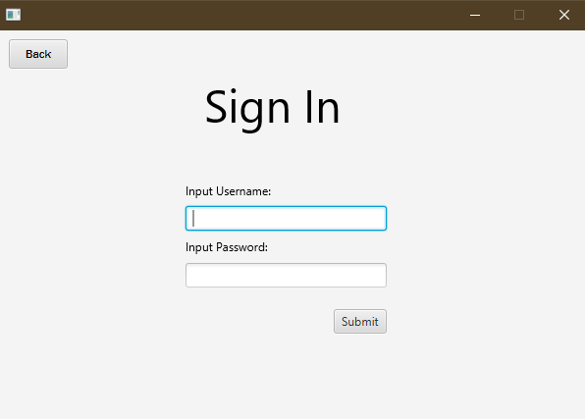  
 insert the new username and new password and then submit.

**iii. Album page**

If the user successes to login and it will open album page

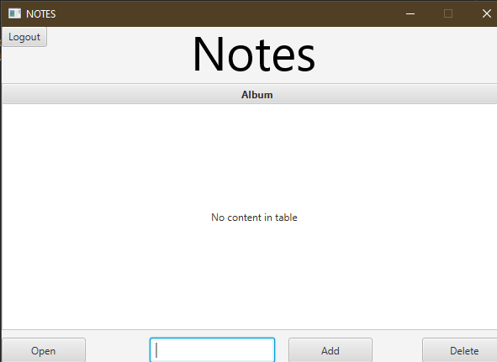  
 input the title of the new album and then press add button.

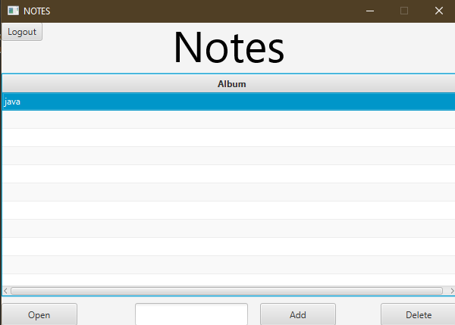

Press java album.

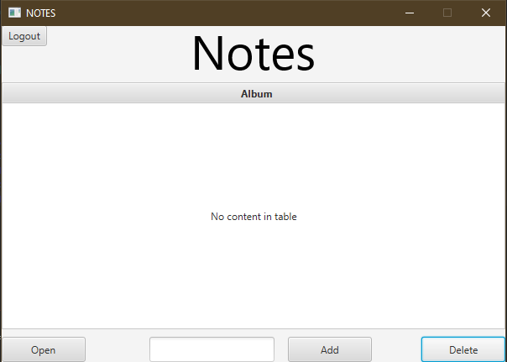

If the user wants to delete album just select the album and press delete button.

**iv. Notes Page**

This page will be open after the user selects the album and press open button.

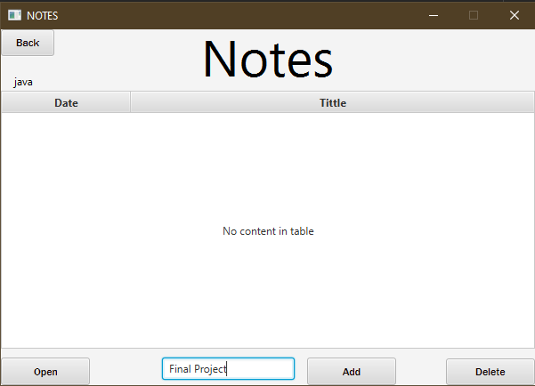  
same with on album page, the user needs to create a new note and input the tittle.

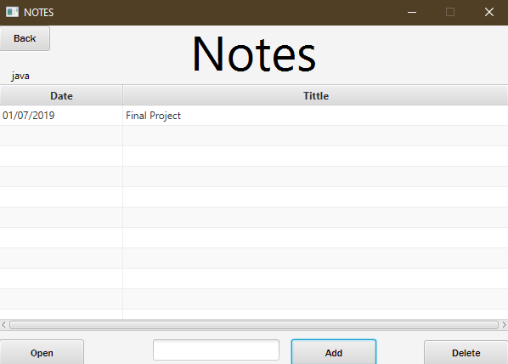  
the user needs to open the note to write down anything that the user wants to write.

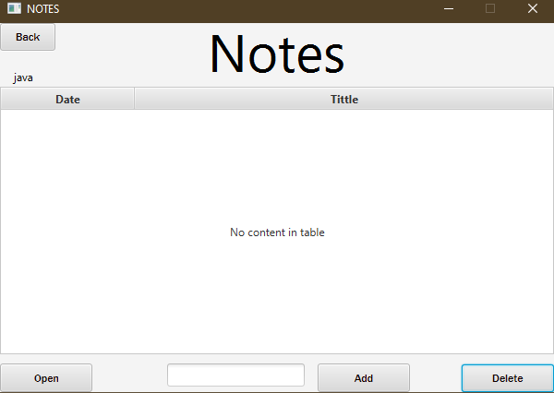

Selects the note and press delete button to delete a note.

**v. Inside Notes**

This page is where the user will write all what the user wants to write.

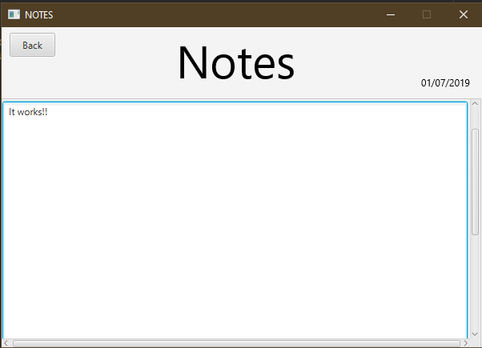  
After the user write down a words to save the words, the user needs to press the back button and it will be save in its own.

**VII. Reference**

<https://dzone.com/articles/getting-current-date-time-in-java>

<https://www.youtube.com/watch?v=FLkOX4Eez6o>

<https://stackoverflow.com/questions/25985410/in-java-how-to-drop-sqlite-table>

FULL CODE(<https://github.com/welydharmaputra/Final-Project/tree/master>)